# GRAPHICAL REPRESENTATION OF DATA

A graphical representation is a visual display of data and statistical results. Representation of statistical data by diagrams, charts or pictures is more effective than tabular representation. Indeed, diagrams are almost essential whenever it is required to convey any statistical information to the general public. Furthermore, any hidden trend present in the given data can be noticed only in this mode of representation. It must be stated, however, that information on a limited number of topics only can be presented in a single diagram so as to maintain its neatness. Moreover, a diagram can give only a rough idea about the magnitude of variation, whereas in a table the exact values may be quoted.

Some of the important tools of graphical representation are:

* Line diagram
* Bar diagram
* Pie diagram
* Histogram, Frequency polygon and Ogives

**Line Diagram**

Graphs represented by line segments may be considered as line graphs. Line graph is a graph that uses line segments to connect data points and shows changes in data over time.

* A line chart is often used to visualize a trend in data over intervals of time. In a time series thus the line is often drawn chronologically.
* In line graph Y axis represent frequency and X axis represent time or period.
* Line graph are usually drawn to represent the time series data, e.g. Temperatures, Rainfall, Population growth, Birth rates etc.
* When the time series exhibit a wide range of fluctuations, we may think of logarithmic or ratio chart where "Log y" and not "y" is plotted against "t".

A **logarithmic scale** (or **log scale**) is a way of displaying numerical data over a very wide range of values in a compact way—typically the largest numbers in the data are hundreds or even thousands of times larger than the smallest numbers. Such a [scale](https://en.wikipedia.org/wiki/Scale_(measurement)) is [nonlinear](https://en.wikipedia.org/wiki/Nonlinear): the numbers 10 and 20, and 60 and 70, are not the same distance apart on a log scale. Rather, the numbers 10 and 100, and 60 and 600 are equally spaced. Thus ***moving a unit of distance along the scale means the number has been multiplied by 10 (or some other fixed factor).*** Often [exponential growth](https://en.wikipedia.org/wiki/Exponential_growth) curves are displayed on a log scale, otherwise they would increase too quickly to fit within a small [graph](https://en.wikipedia.org/wiki/Plot_(graphics)). Another way to think about it is that the *number of*[*digits*](https://en.wikipedia.org/wiki/Numerical_digit) of the data grows at a constant rate. For example, the numbers 10, 100, 1000, and 10000 are equally spaced on a log scale, because their numbers of digits is going up by 1 each time: 2, 3, 4, and 5 digits. In this way, adding two digits *multiplies* the quantity measured on the log scale by a factor of 100.

* We use **multiple line charts** for representing two or more related time series data expressed in the same unit and **multiple-axis line chart** in somewhat similar situations, if the variables are expressed in different units.

**Example of Simple Line Chart:**

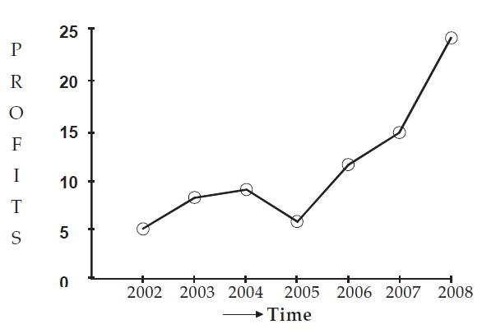

**Fig.1:** Profit (in lakhs) of an Industrial House during 2002 to 2008

**Example of Multiple Line Chart:**

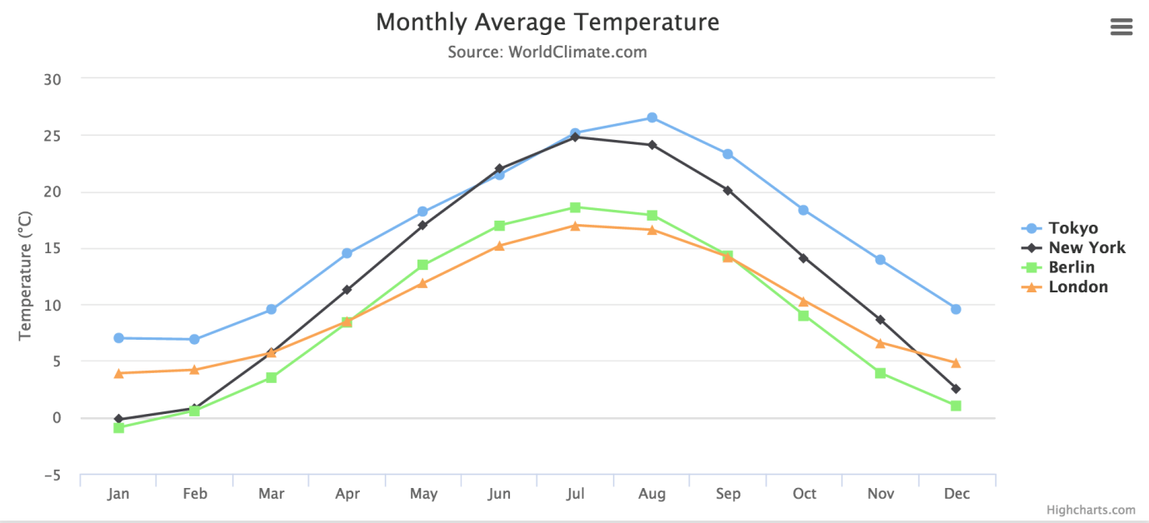

**Fig. 2:** Monthly temperature in Tokyo, New York, Berlin and London in a year

**Example of Multiple-axis Line Chart:**

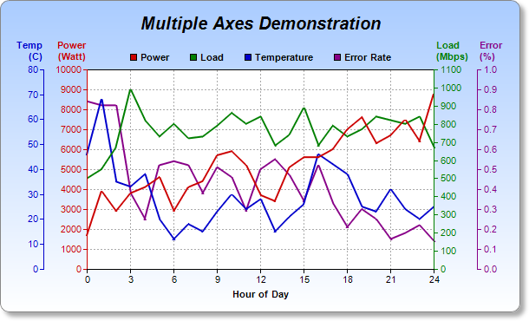

**Fig. 3:** Hourly Temp., Power cons., Load and Error rate over a day

**Example of Logarithmic Line Chart:**

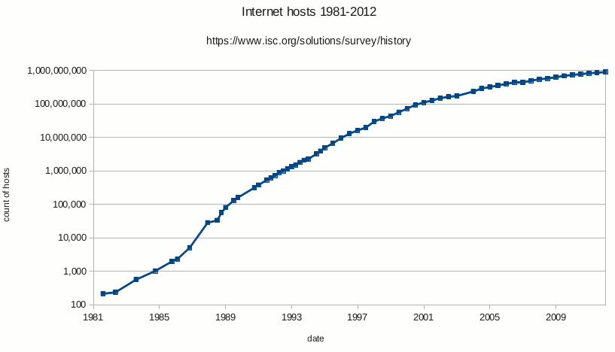

**Fig. 4:** The Internet host count over time shown on a logarithmic scale

## Bar Diagram

A Bar graph is a chart with rectangular bars of equal width with length proportional to the values that they represent. The bars can be plotted vertically (vertical bar diagram) or horizontally (horizontal bar diagram).

Generally, ***horizontal bar diagram is used for nominal/ categorical data*** and the ***vertical bar diagram is used for ordinal/sequential data or time series data***.

**Example of Horizontal Bar Diagram:**

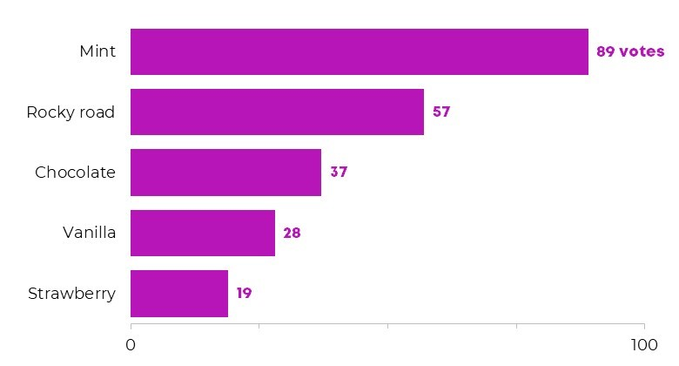

**Fig. 5:** Bar diagram of favourite ice cream flavours

**Example of Vertical Bar Diagram:**

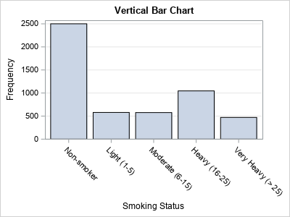

**Fig.6:** Bar diagram of smoking status in surveyed people

A bar graph will have two axes. One axis will describe the types of categories being compared and the other will have numerical values that represent the values of the data.

There are many different types of bar graphs. Each type will work best with a different type of comparison.

**Simple bar diagram:** It represents only one variable. For example sales, production, population figures etc. These are in same width and vary only in heights. It becomes very easy for readers to study the relationship. It is the most popular in practice.

**Sub-divided bar diagram**: While constructing such a diagram the various components in each bar should be kept in the same order. The components are shown with different shades or colours with a proper index. Sub divided bar diagrams are applied for representing data divided into a number of components.

**Example of Sub-divided Bar Diagram:**

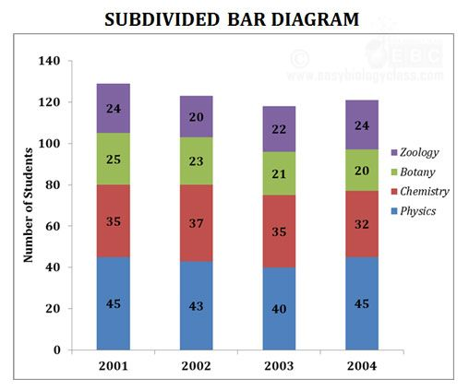

**Fig. 7**: Subdivided bar diagram of students in different sections

**Multiple or Grouped bar diagram**: In a multiple bars diagram two or more sets of inter-related data are represented and it facilitates comparison between more than one phenomena. The technique of making a simple bar chart is used to draw this diagram but the difference is that we use different shades, colours, or dots to distinguish between different phenomena. We draw multiple bar charts if the total of different phenomena is meaningless.

**Example of Multiple/Grouped Bar Diagram:**

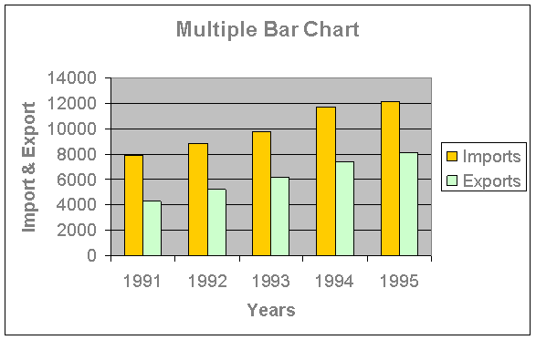

**Fig. 8:** Multiple bars diagram of import and export during 1991-95

**Deviation bar diagram**: Deviation bar graphs are simply two bar charts aligned, where one of the charts runs right to left rather than left to right. The two charts report on the same categories but differ in terms of respondent group or some other variable. Thus, the shared categories, such as the survey questions, are listed in the space in the middle of the two bar charts. Usually, these are constructed as bar charts, where the bars are horizontal, not column charts.

The purpose of graphing each set of responses separately from one another is so that it is easier to see the shape of each response set. Thus ***it is important to order one of the response sets from greatest to least, so that it is easier for a viewer to see where the other response set is out of shape.***

Deviation bars are also ***used to represent net quantities*** - ***excess or deficit***, i.e. net profit, net loss, net exports or imports, swings in voting etc. Such bars have both positive and negative values. Usually, these are constructed as bar charts, where the bars are vertical, not horizontal. Positive values lie above the base line and negative values lie below it.

**Examples of Deviation bar Diagrams:**

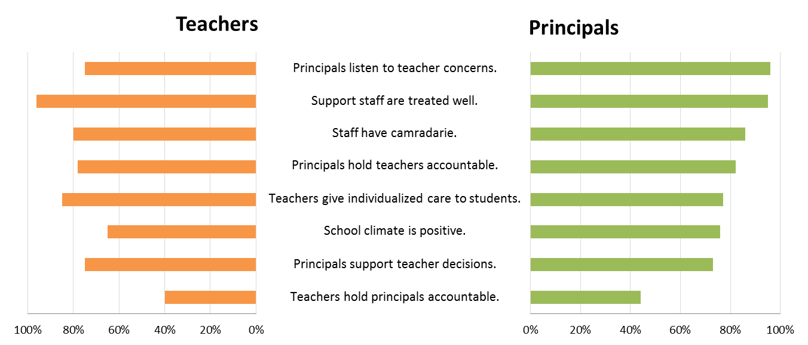

**Fig. 9:** The responses of teachers and principals to the common survey questions

The Sales and Net profits data of a company in three financial years are given below:

|  |  |  |
| --- | --- | --- |
| Year | Sales | Net profits |
| 1985-86  1986-87  1987-88 | 10%  14%  12% | 50%  -20%  -10% |

Present the above data by a suitable diagram showing the sales and net profits of the company.

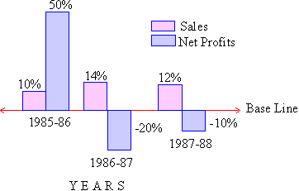

**Fig. 10:** The Sales and Net profits during 1985-86 to 1987-88

## Pie Chart (or Circle chart)

In a pie chart, the various observations or components are represented by the sectors of a circle and the whole circle represents the sum of the value of all the components. Clearly, the total angle of 360° at the center of the circle is divided according to the values of the components.

* The central angle of a component is

= [Value of the component / Total value] x 360°

Sometimes, the values of the components are expressed in percentages. In such cases,

* The central angle of a component is

= [Percentage value of the component / 100] x 360°

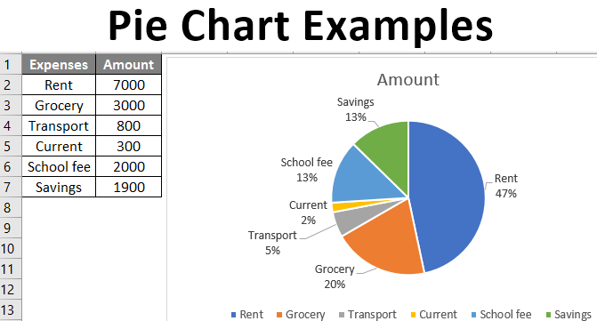

**Fig. 11: Pie chart of monthly expenses**

# Exercises:

1. The daily earnings of a store for a week are shown below. Represent the information on a line chart.

|  |  |  |  |  |  |  |  |
| --- | --- | --- | --- | --- | --- | --- | --- |
| Day | Mon | Tues | Wed | Thurs | Fri | Sat | Sun |
| Earnings | 300 | 450 | 200 | 400 | 650 | 500 | 850 |

1. The numbers of hours spent by a child on different activities on a working day are shown below. Represent the information on a pie chart.

|  |  |
| --- | --- |
| **Activity** | **No. of Hours** |
| School | 6 |
| Sleep | 8 |
| Playing | 2 |
| Study | 4 |
| T. V. | 1 |
| Others | 3 |

1. The population growth (in millions) over three decades in five countries are shown below.  Represent the information on a multiple bar graph.

|  |  |  |  |
| --- | --- | --- | --- |
| **Country** | **1980** | **1990** | **2000** |
| France | 55 | 56 | 65 |
| United Kingdom | 50 | 53 | 63 |
| Mexico | 65 | 78 | 80 |
| Nigeria | 60 | 82 | 85 |
| Pakistan | 57 | 65 | 74 |

1. The production of wheat, barley and oats (in 100 kg) during the years 1991 to 1994 are shown below:

|  |  |  |  |
| --- | --- | --- | --- |
| **Years** | **Wheat** | **Barley** | **Oats** |
| 1991 | 34 | 18 | 27 |
| 1992 | 43 | 14 | 24 |
| 1993 | 43 | 16 | 27 |
| 1994 | 45 | 13 | 34 |

Construct a component bar chart to illustrate this data.

1. Represent the following data relating to net export of a company by deviation bar diagram.

|  |  |  |  |  |  |  |
| --- | --- | --- | --- | --- | --- | --- |
| Year | 2012 | 2013 | 2014 | 2015 | 2016 | 2017 |
| Net Export  (Rs. in Cores) | 250 | 160 | -80 | 50 | -110 | 70 |